**ABSTRACT**

**IoT enabled robot for detecting gas pipe leakage**

An IOT enabled robot for gas leakage detection that can traverse pipes horizontally as well as vertically while efficiently overcoming obstacles. The processing unit (1)receives input from the gas sensor (2) and the temperature humidity sensor (7) to detect gas leaks . The imaging device (5) is used to provide visual inspection . The strong magnets (4) beneath enable the robot to adhere to the pipes. The castor wheels (9) assist the robot to climb pipes vertically and overcome obstacles. The ultrasonic sensor (6) detects the proximity of obstacles, ensuring the robot avoids collisions with them . The processing unit (1) tracks the location and sends alert to the monitoring and control center (11) if gas leakages are detected.

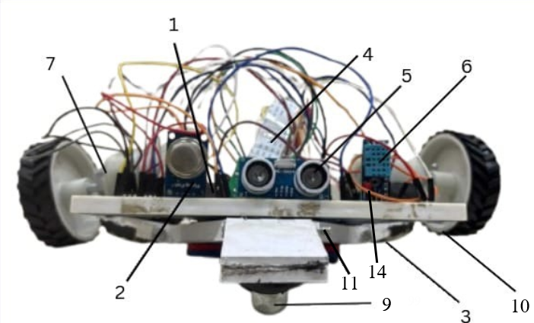

Figure 1



**Shah Shashwat Nimesh**

Applicant